Retail One training course

Retail One pos

Soluone

INDEX

Interface

Administration

Restaurant

* Restaurant
* Fast food

Operations

* Sales
* Returns
* X/Z Report

Inventory

* Inventory transfer outbound
* Inventory transfer inbound
* Goods issue
* Entry of goods
* Inventory count

Reports

Additional

INTERFACE

Main screen

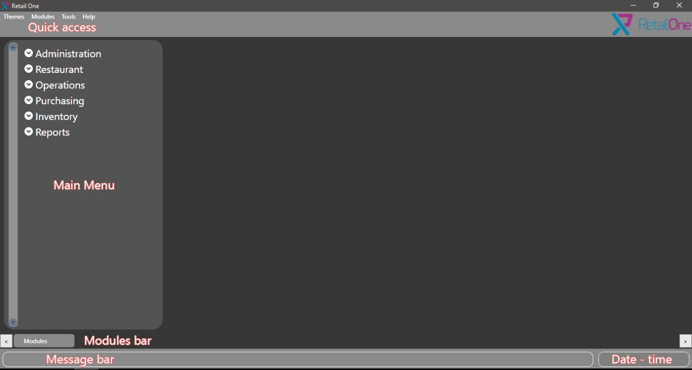

Sales screen

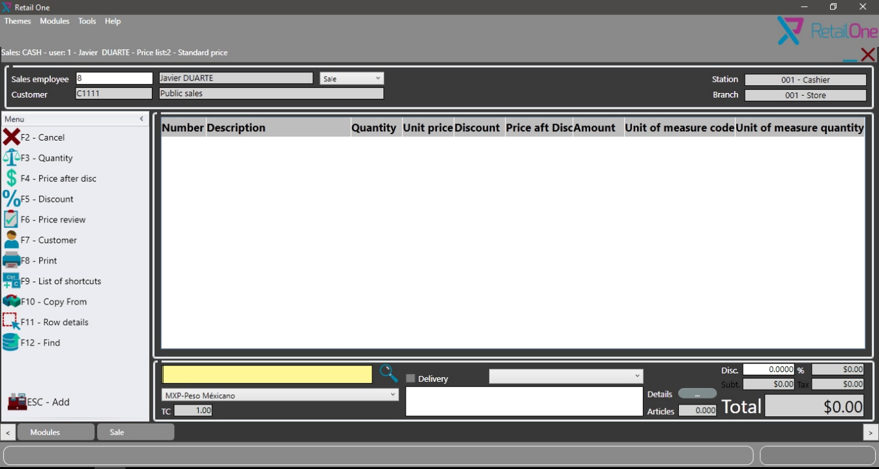

Sales touch screen

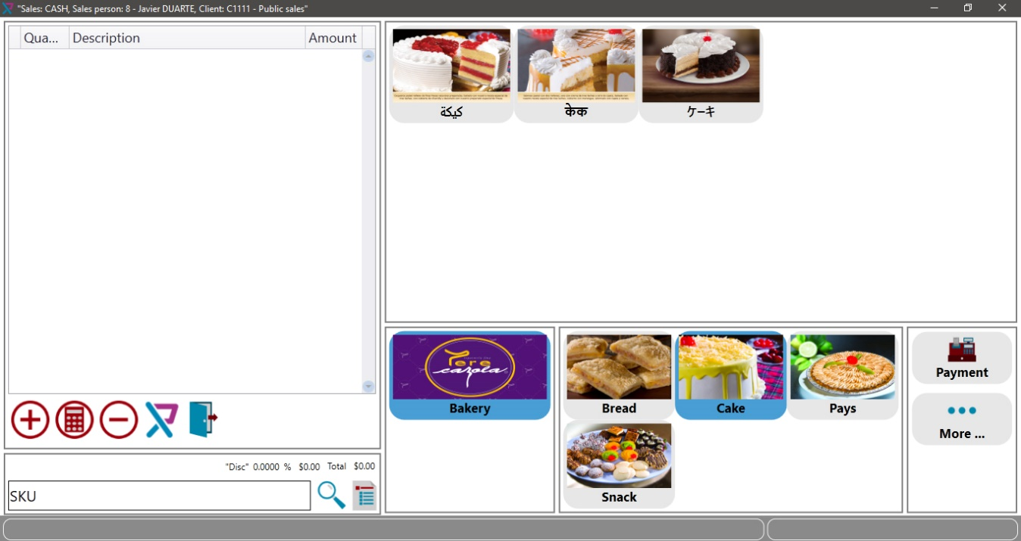

ADMINISTRATION

This section is for configurations, in this section we have connectivity for set SQL connection and Exchange rate for set currency exchange if we use different currencies.

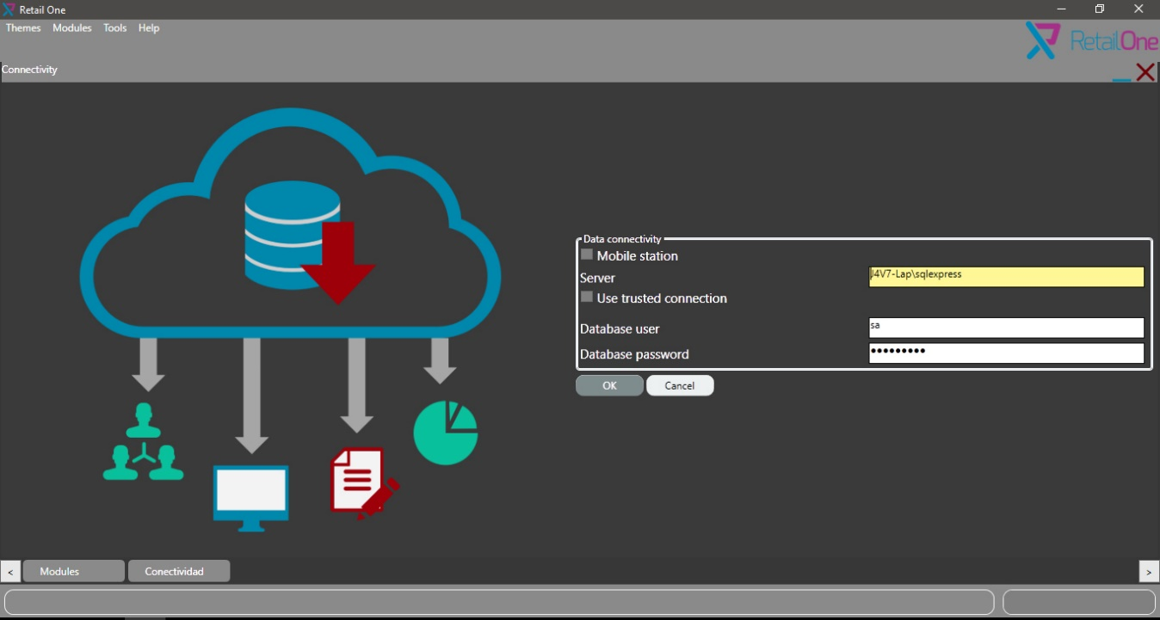

RESTAURANT

In Restaurant, we can design the table map like real world for locate easily the table by the waiter.

For map tables, we access to Restaurant>Distribution

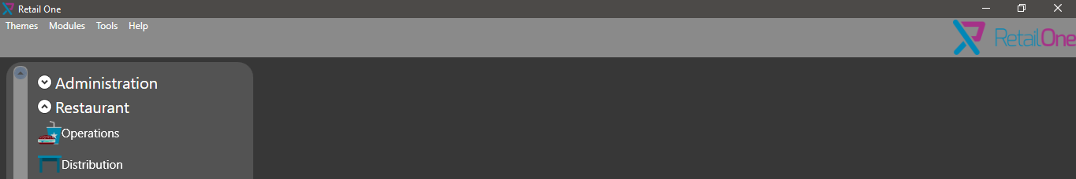

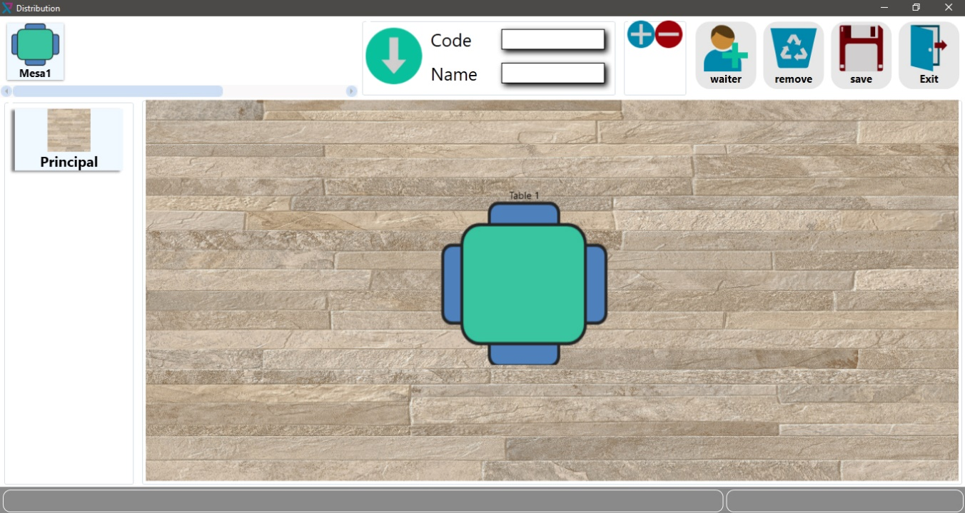

Restaurant mode use table for assign orders, we can manage many tables.

For access to this module we click in Restaurant>Operations



Operations

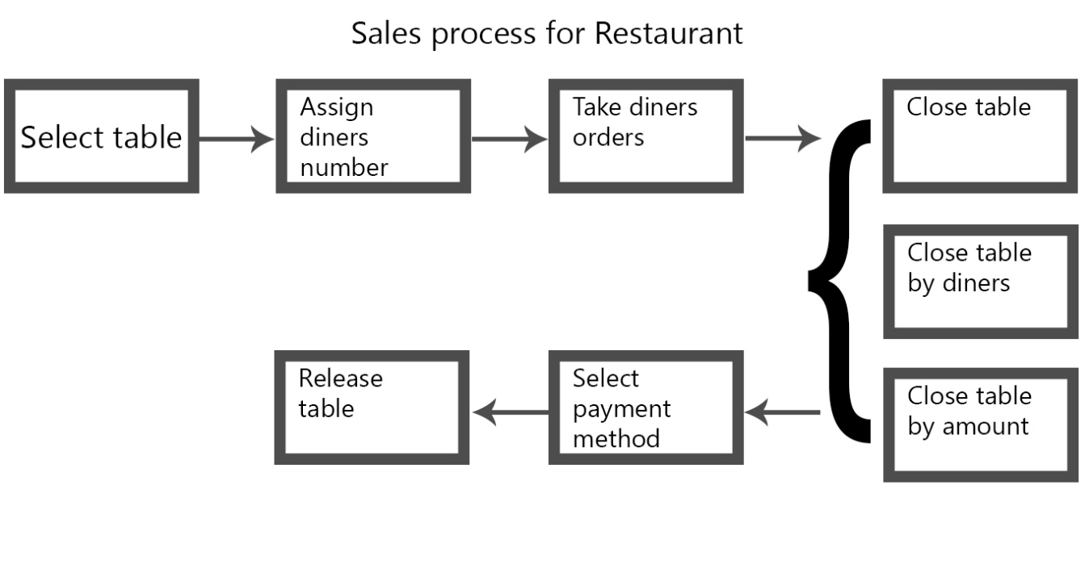

In this architecture, we need select a table for begin the sale process, in previous diagram we have the flow for complete a sale.

Select table:

In this screen, we have table distribution.

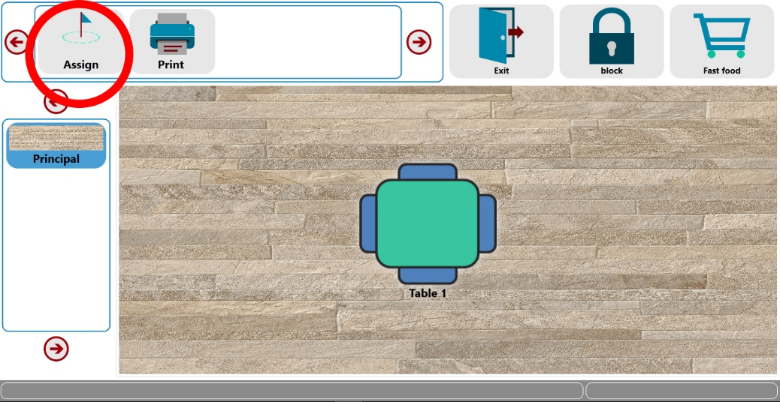

Assign diners number:

In this windows we select initial diners quantity, we can add more diners later.

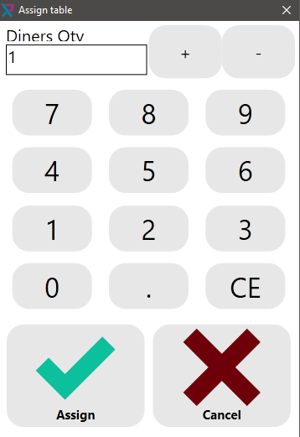

Take diners orders:

Once we select diners quantity, we proceed to take the orders selecting order button.

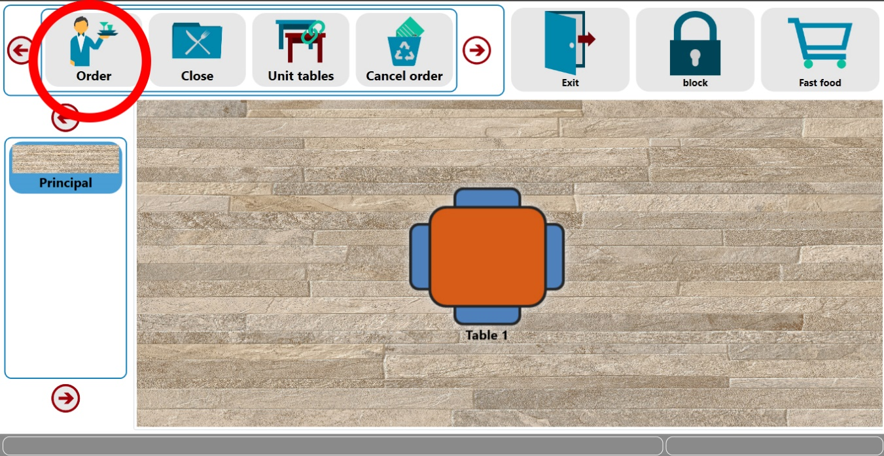

After click order button we can select the items, in this windows we can navigate in menus for find the specified item or write the item code.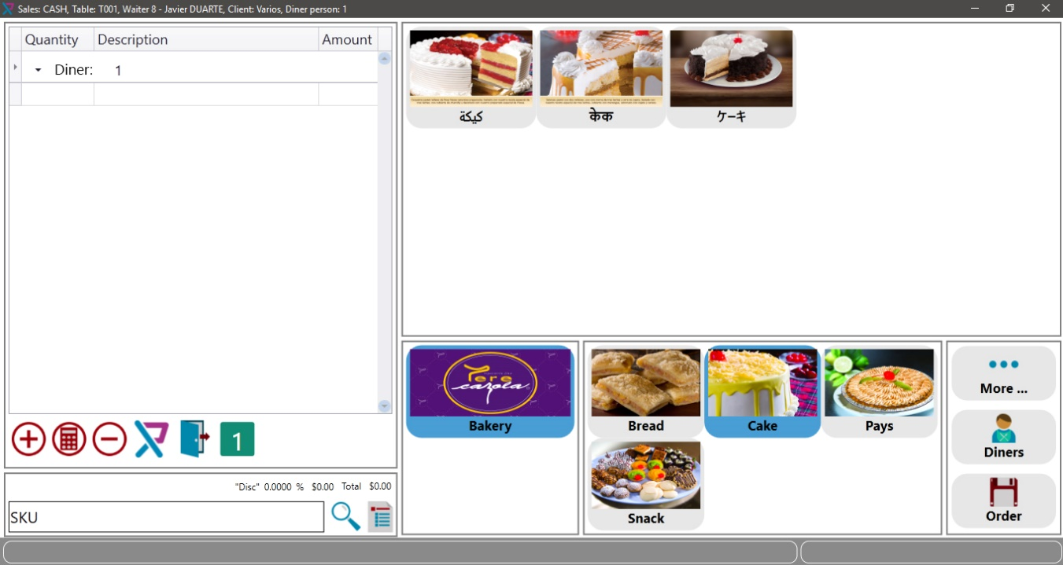

Close table:

After close the table we can´t add more items.

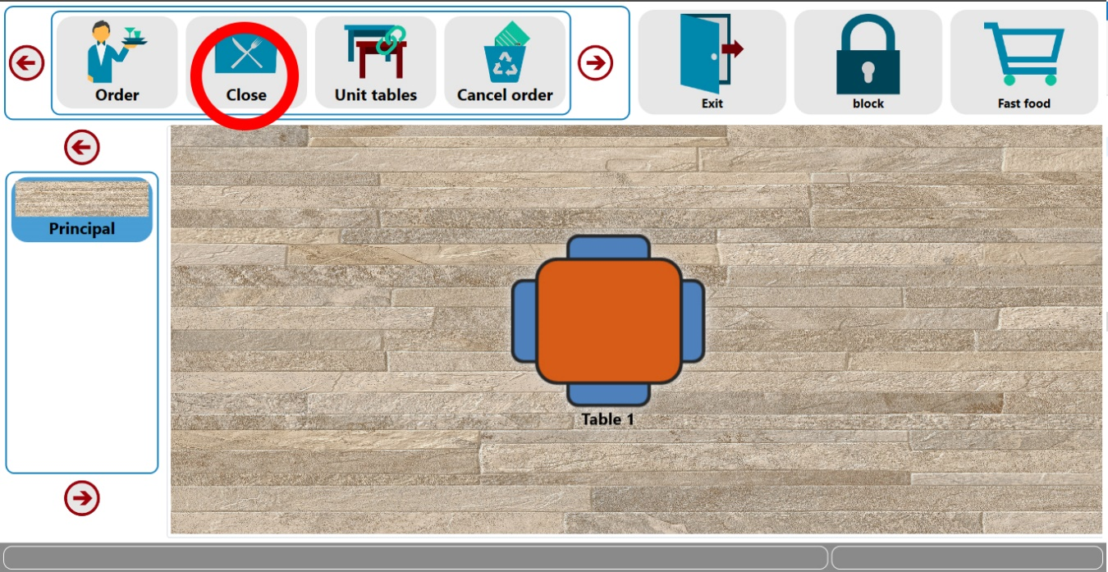

For close table there are three options: Include all items in one invoice, divided by diners or divided by amount.

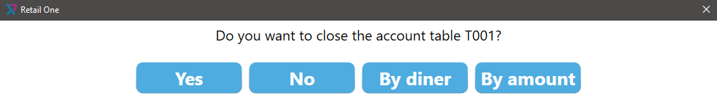

Divided by diner window:

This screen is for select different customers for create his invoice.

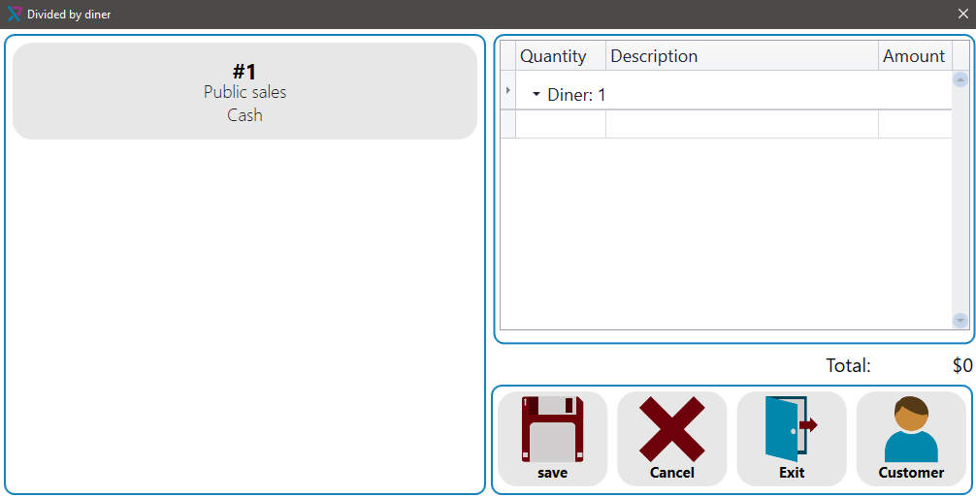

Divided by amount window:

This screen is for select the amounts for pay total amount in different invoices.

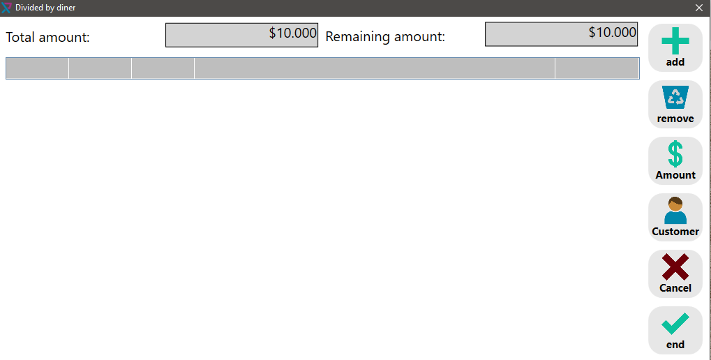

Select payment method:

Once the table is close, we click payment button for select payment method.

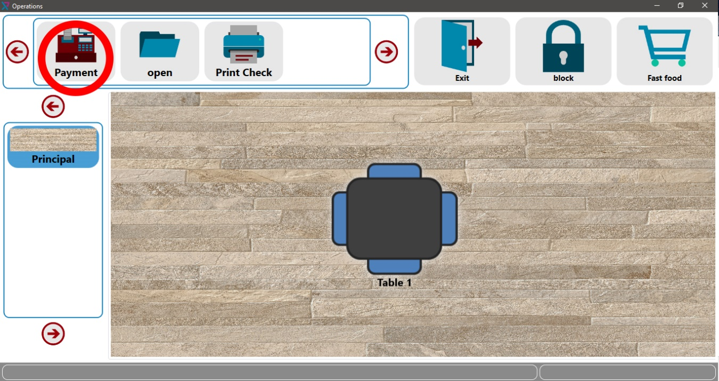

This screen let select different payment methods for pay the invoice.

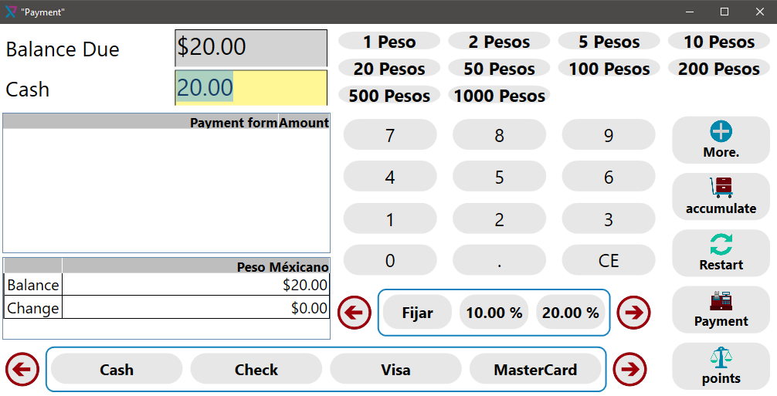

Release table:

Once the invoice was paid, the table is available for start again the sale process.

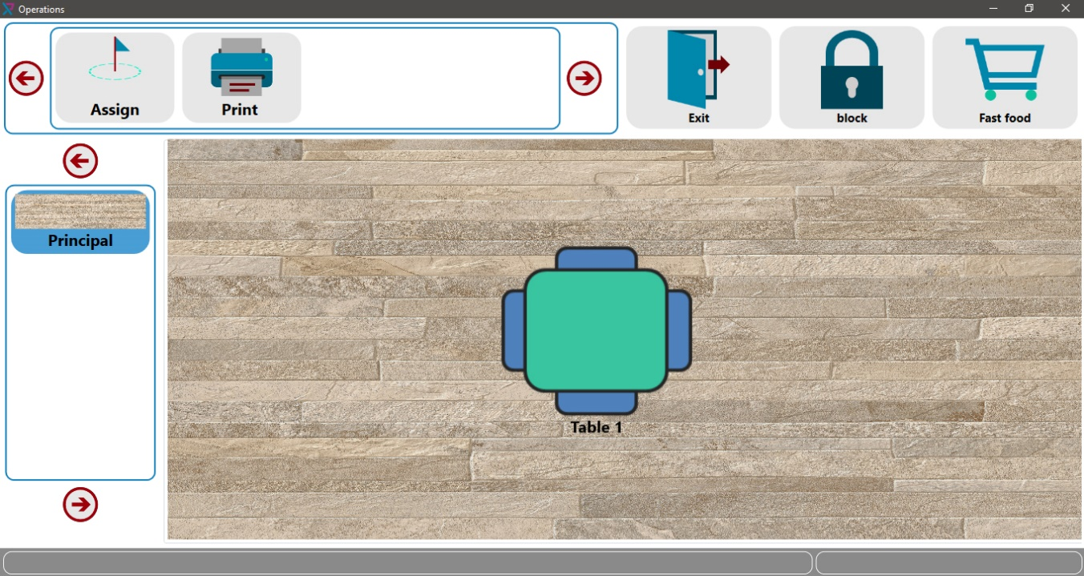

FAST FOOD

In fast food mode, we create invoice directly selecting items in a touch screen menu

For access to this module we click in Restaurant>Fast food

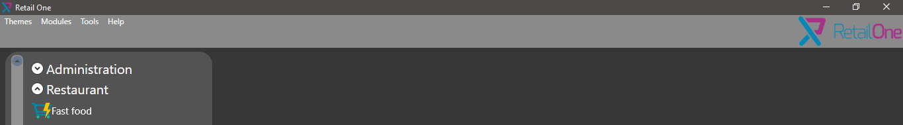

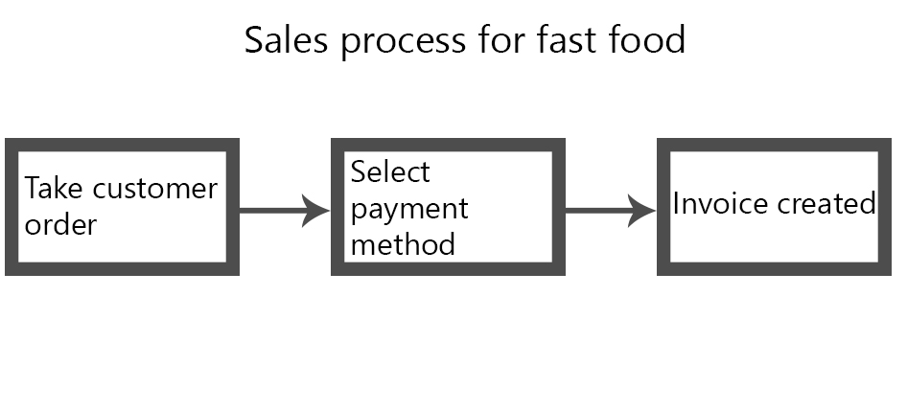

Take customer order:

Fast food doesn't have table, in this mode this invoice is created selecting items in a visual menu



Select payment method:



This screen is like restaurant, we can select different payment methods.

Invoice created:

Clicking payment button, we create the invoice and we can start this process again.

SALES

This module is designed for work quick with hotkeys.

For access to this module we click in Operations>Sales

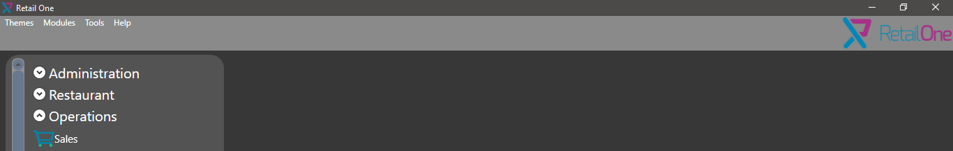

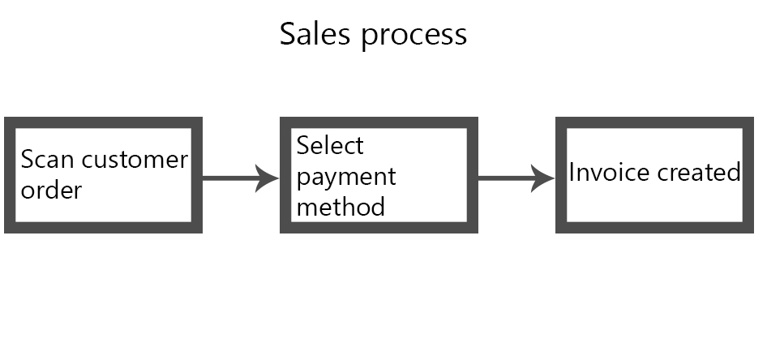

This screen is for scan customer items, also in this screen we can change customer, apply a discount, change price, change tax, etc.

On right we have a menu with different option for change sales parameters.

On bottom, we have scan text box, remarks text box and total area.

On top, we have sale head data.

For add items to invoice, we need enter item barcode or the Itemcode (it depends configuration).

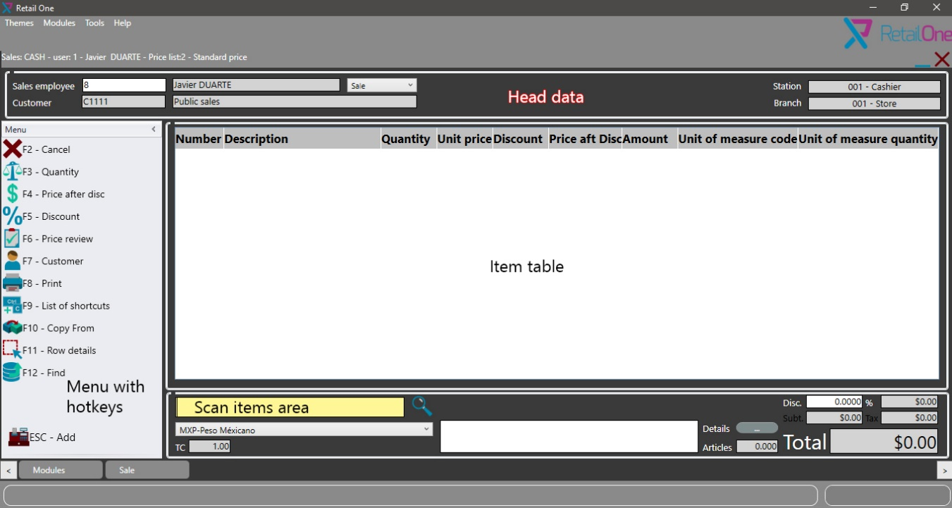

After click in add button, the next screen is for confirm customer data, we can update customer information.

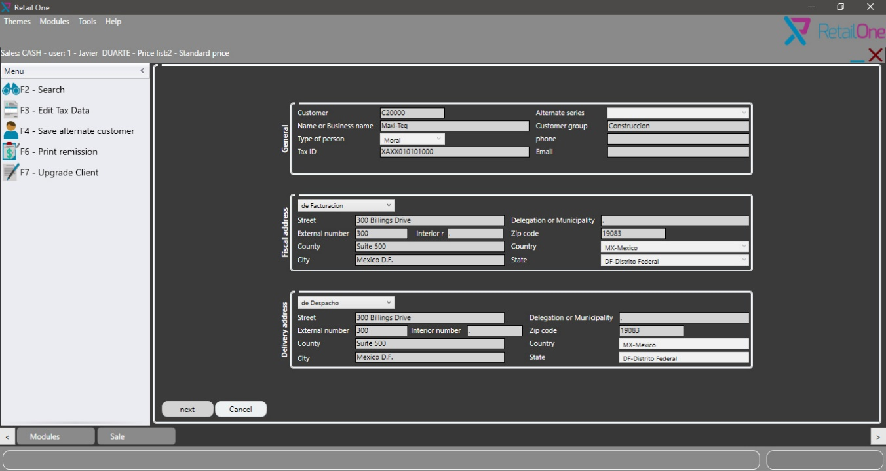

For select payment method, we need to enter the amount in textbox and select with function key the payment method, depend of payment method is need to insert additional information like credit card number or check folio.

For payment methods with additional information we need select two times the option, one for choice and the second for save additional information.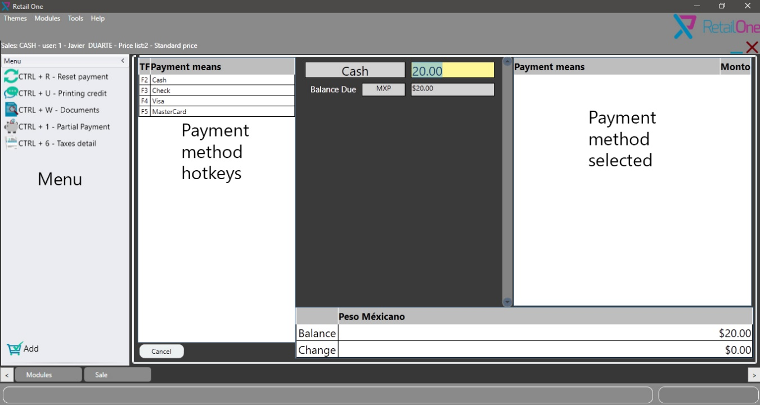

RETURNS

This module permit return customer invoice created in Retail One.

For access to this module we click in Operations>Returns

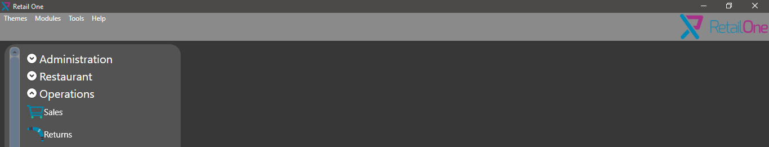

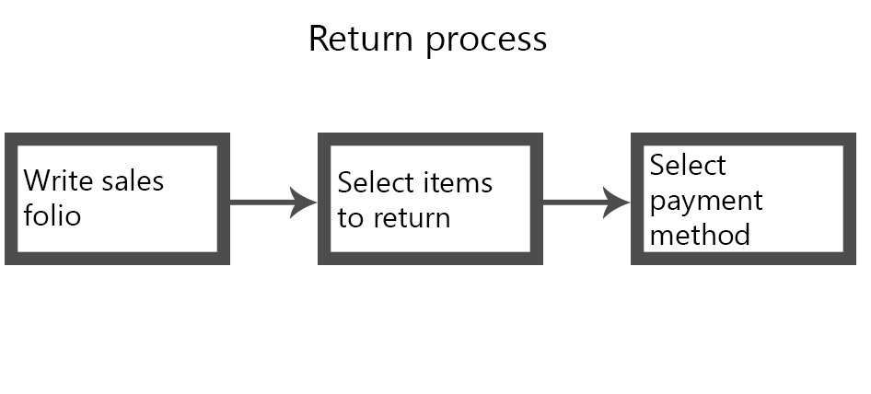

For begin the process we need enter the invoice folio in text box.

We can realize the total return or partial return by unmarking return column.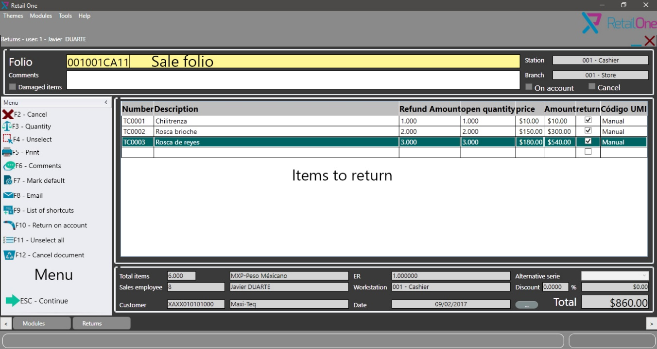

Once finished items selection, we select payment method for refund the customer, this screen is like sale payment screen.

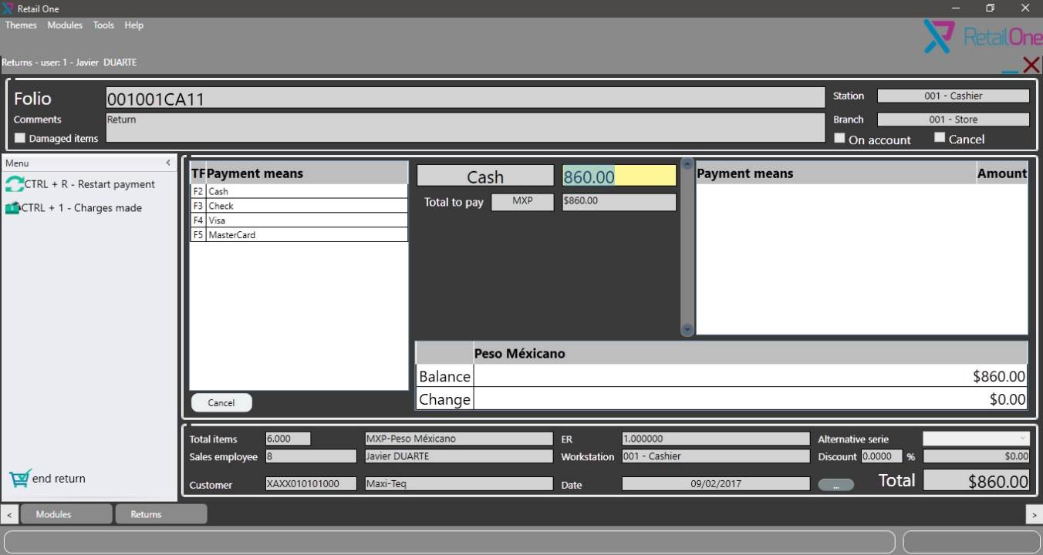

X/Z REPORT

X/Z reports module permit generate money movement reports.

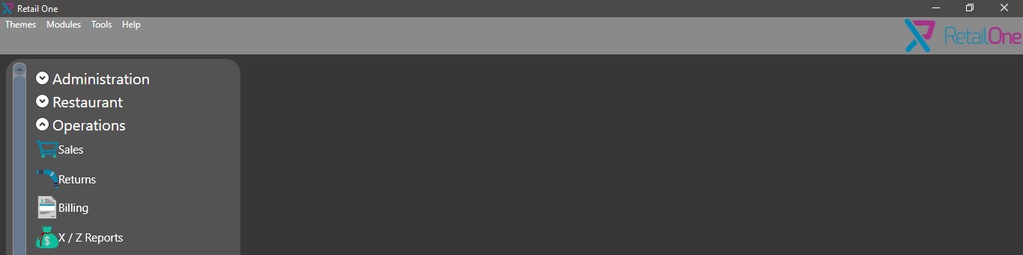

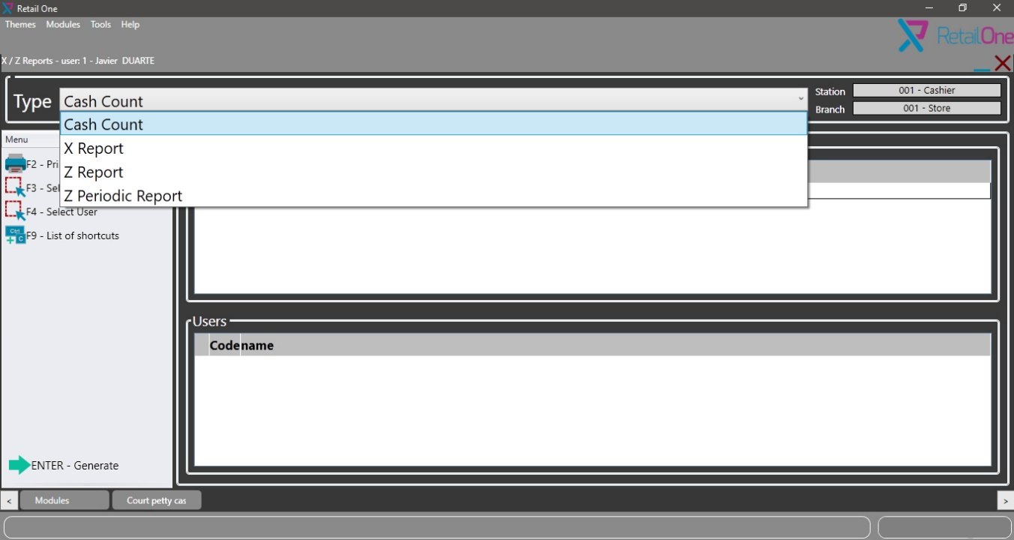

Cash count

Cash count is for generate a report with total money by payment method.

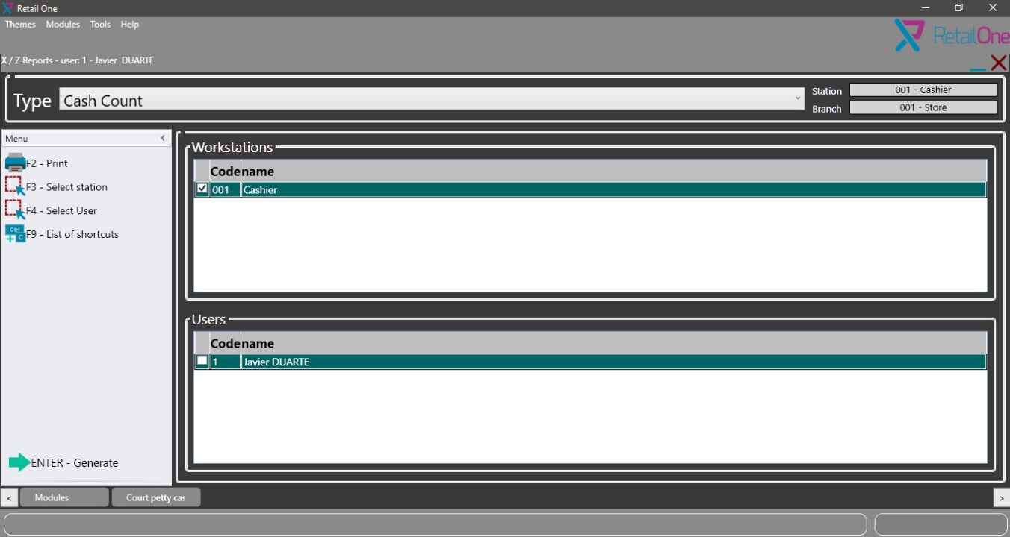

X report is for keep record each shift work in the store, once the current shift work is finished we need generate x report for start the new shift work.

Once all shift works are finished, we need generate z report for end the working day.

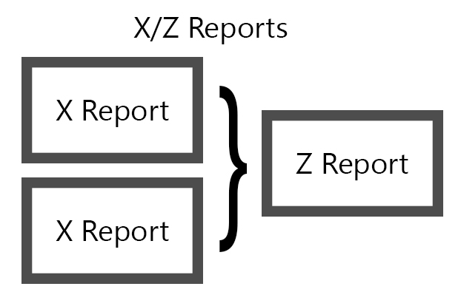

X report

For generate x report the cashier need count total amount by payment methods, and enter the quantity into the table cell.

Once all amounts were entered, click in generate the report for close the current shift work.

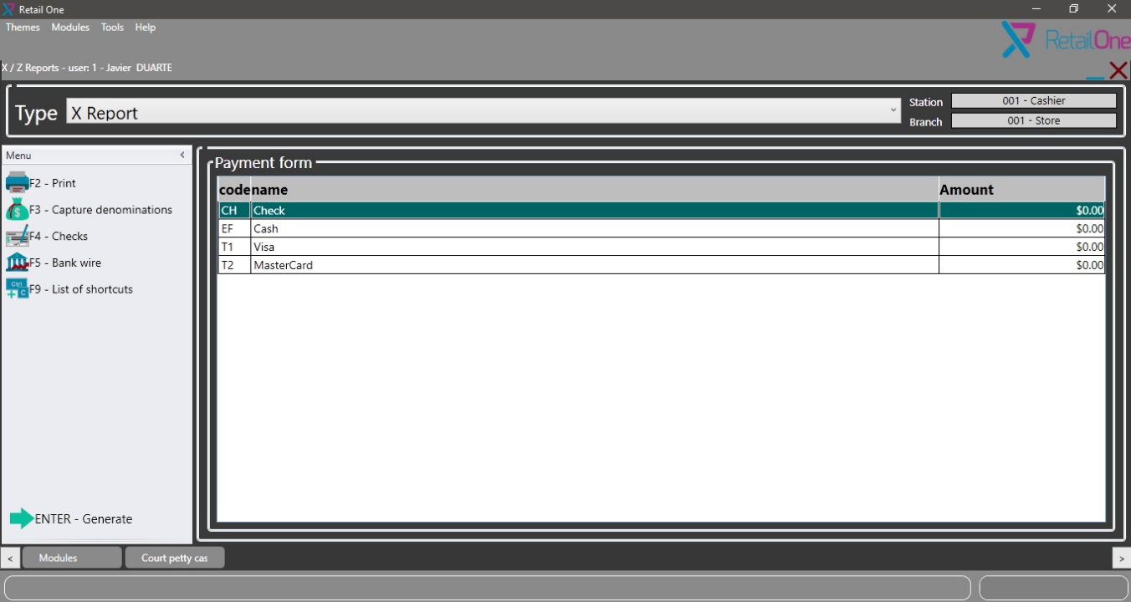

Each time the x report is generated, open cash window is shown before the first sale.

In this screen we introduce the initial cash amount for the cashier.

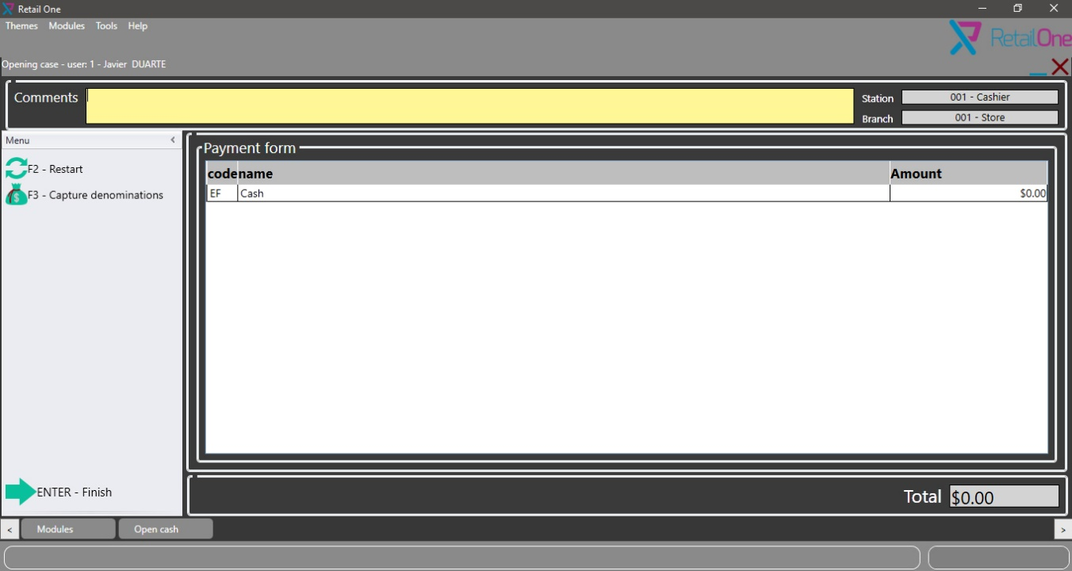

Z report

Before generated is necessary generate all shift works x reports, once all x reports are generated, we click in generate button.

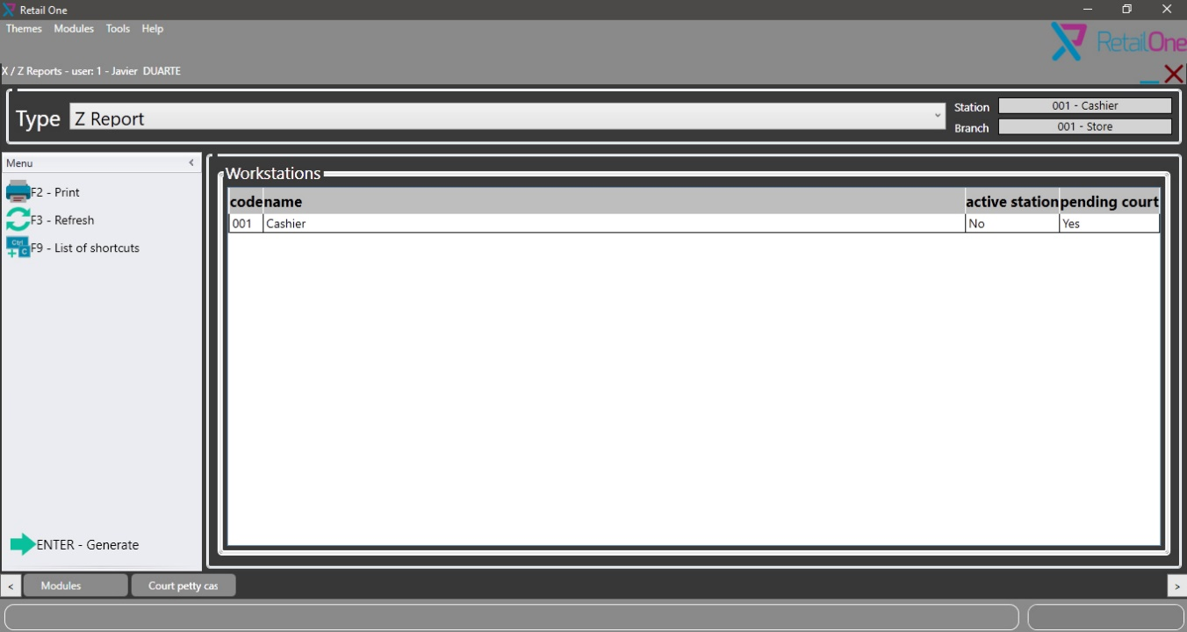

Z periodic report:

This is only for El Salvador.

Transfer

All transfer transaction need a transit warehouse, the transfer need to be received.

For transfer between SAP and POS or POS between POS the flow is similar, we can start using a transfer request or do the transfer direct to transit warehouse, after transfer the items we need to do the reception.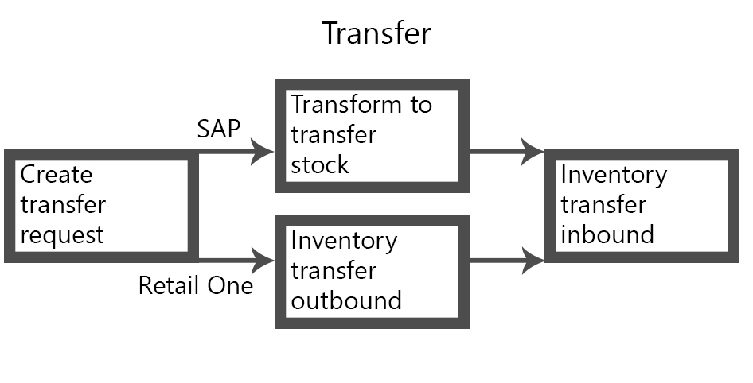

For transfer from SAP to Retail One we need enter in to warehouse the transit warehouse and enter in UDF "Sucursal Destino" the Store code.

Note: in SAP we can't use Retail One warehouse for do transactions directly

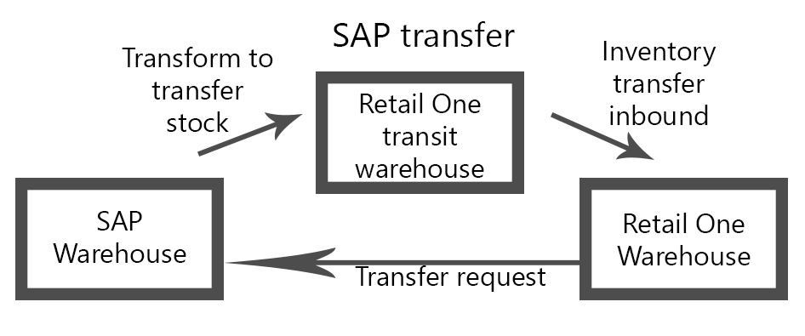

For transfer between Retail one, we use Inventory transfer outbound module and select a destination store.

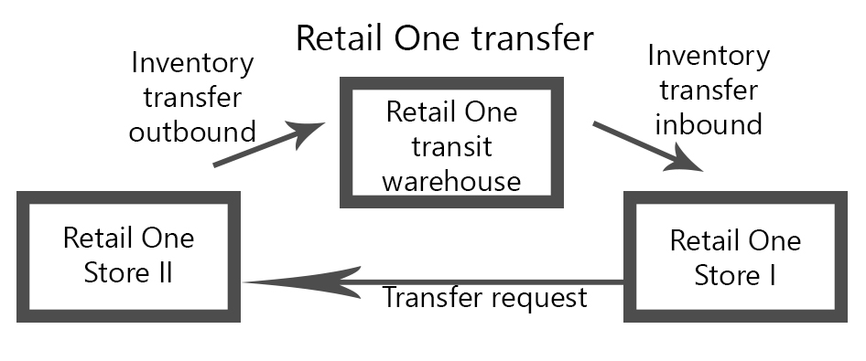

INVENTORY TRANSFER OUTBOUND

This module permit generate inventory transfer outbound and transfer request.

For access to this module we click in Inventory> Inventory transfer outbound.

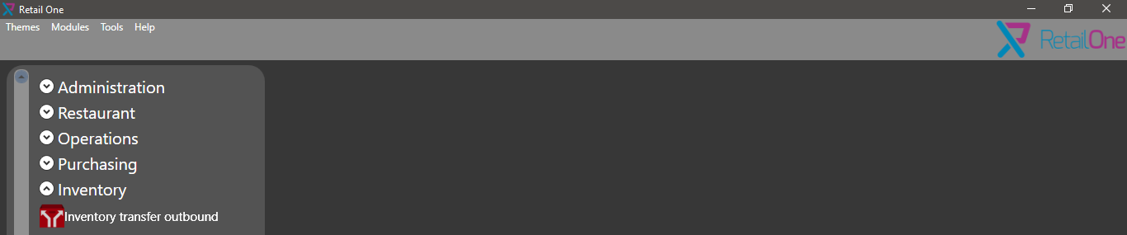

The first step is select the operation.

Next select destination store or external warehouse (SAP warehouse).

Scan items and click in continue.

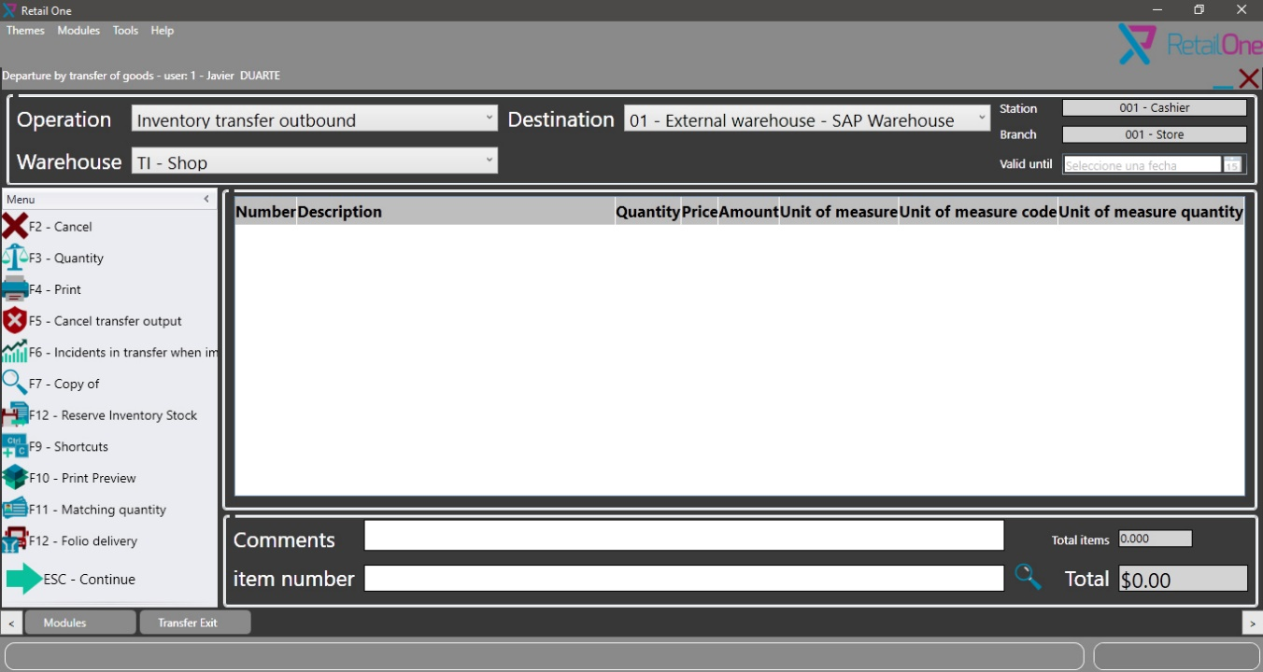

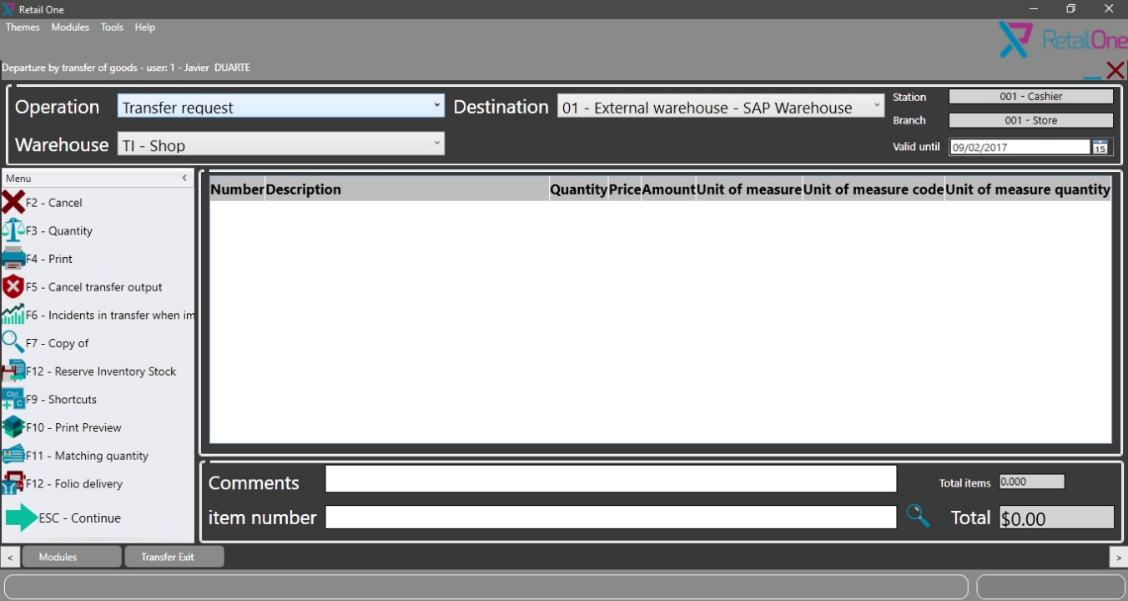

For inventory transfer outbound there are additional data like shipment responsible, driver, etc.

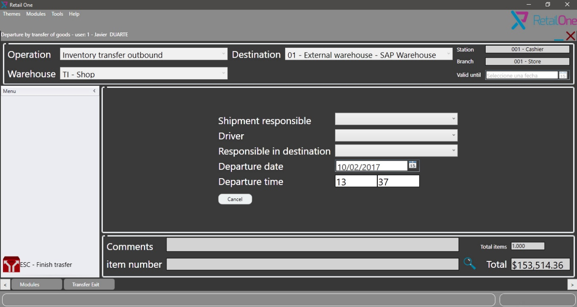

INVENTORY TRANSFER INBOUND

This module permit generates inventory transfer inbound for receipt the transfer.

For access to this module we click in Inventory> Inventory transfer inbound.

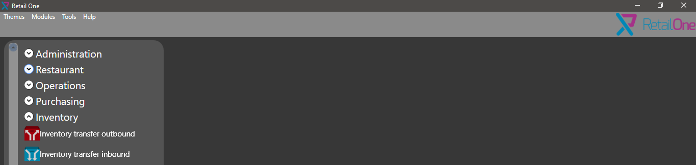

First step is enter the transfer folio.

Next check quantity received, if it isn't correct with F3 or quantity option in menu is possible change.

Once all information is checked click in continue for do the entry.

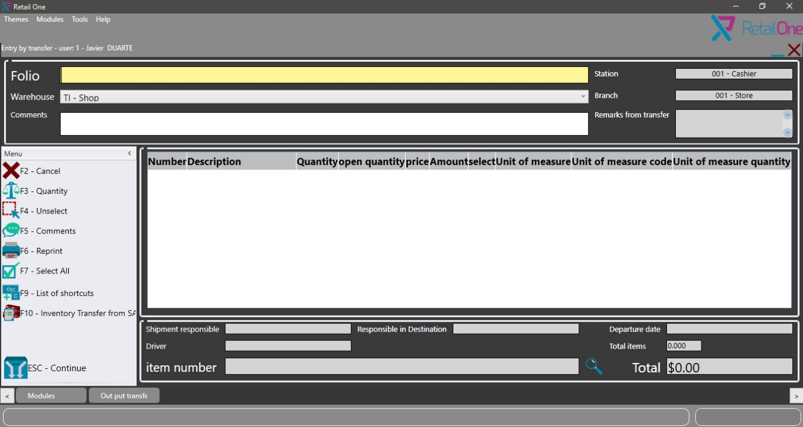

GOODS ISSUE

This module permit decrease the stock by inventory adjustment, this is used when there is stock missing.

For access to this module we click in Inventory> Goods Issue.

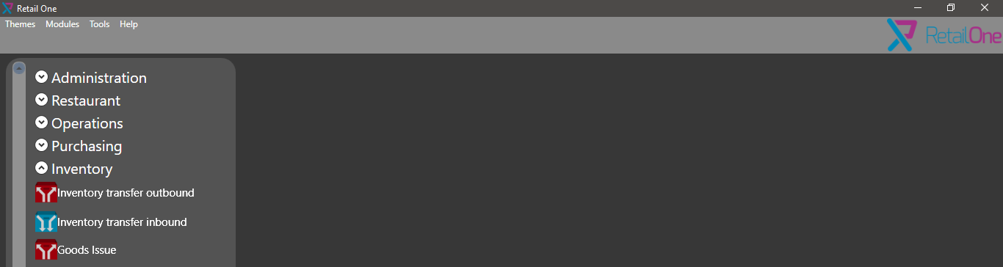

First step is scan items.

Next select quantity with F3 or Quantity from menu.

Write in comments text box the cause.

Click in generate button.

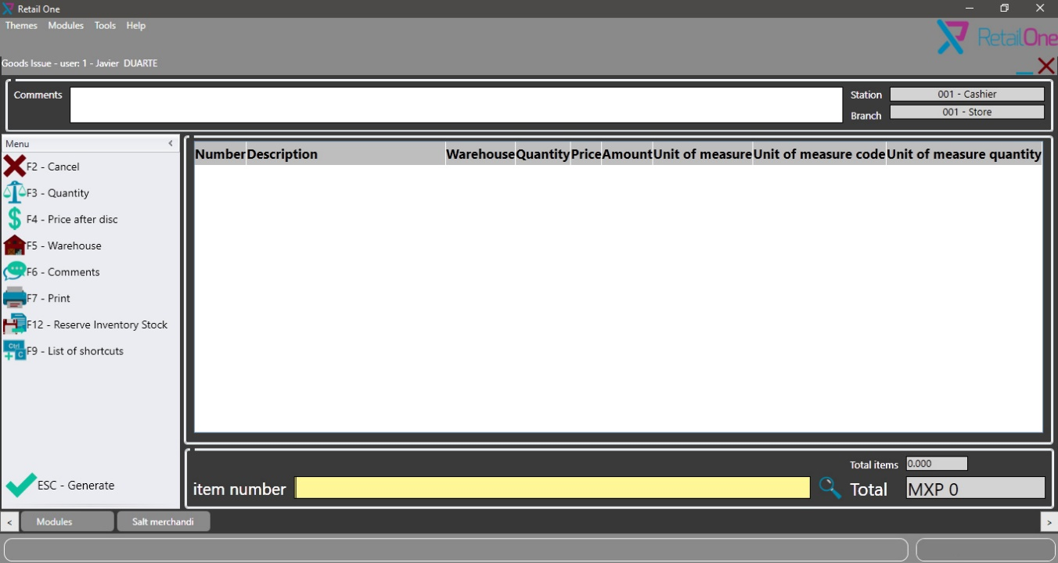

ENTRY OF GOODS

This module permit increase the stock by inventory adjustment, this is used when there is more stock in warehouse than the system.

For access to this module we click in Inventory> Entry of goods.

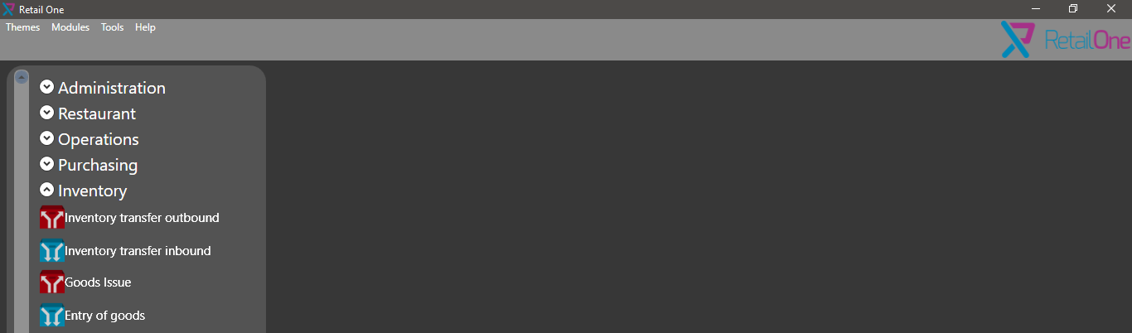

First step is scan items.

Next select quantity with F3 or Quantity from menu.

Write in comments text box the cause for this entry.

Click in generate button.

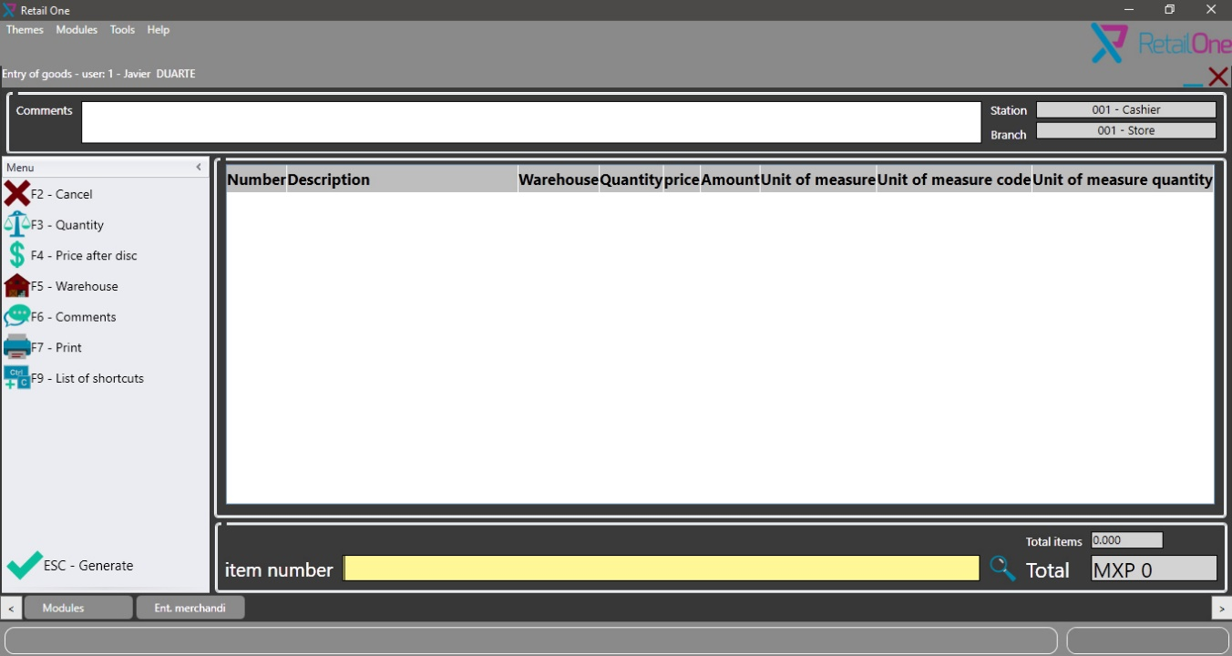

INVENTORY COUNT

This module permit does inventory adjustment, matching system stock with warehouse stock.

For access to this module we click in Inventory> Inventory count.

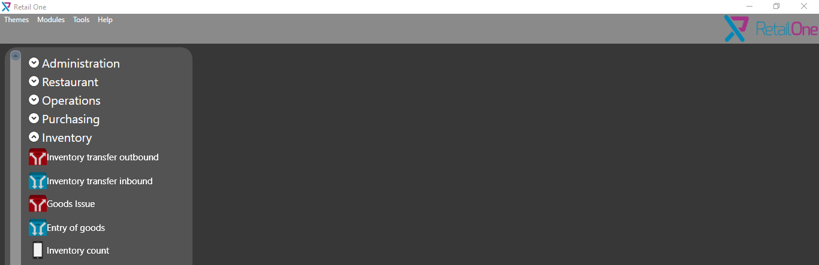

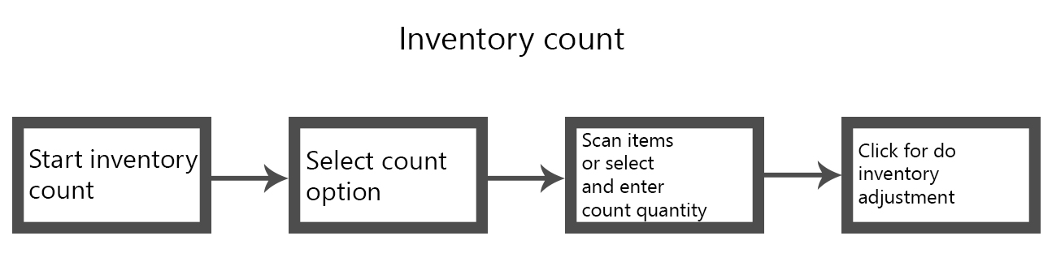

The first step is select count by option.

* Department: Is defined using QtyGroup\* fields in OITM table.
* Line: Is the Item Group.
* Items: Add items by barcode or itemcode
* Locations: Need create location structure (is for specific client).

Once count by option is selected, we click on enter button.

Next the inventory synchronization is started.

After synchronization click again in enter button.

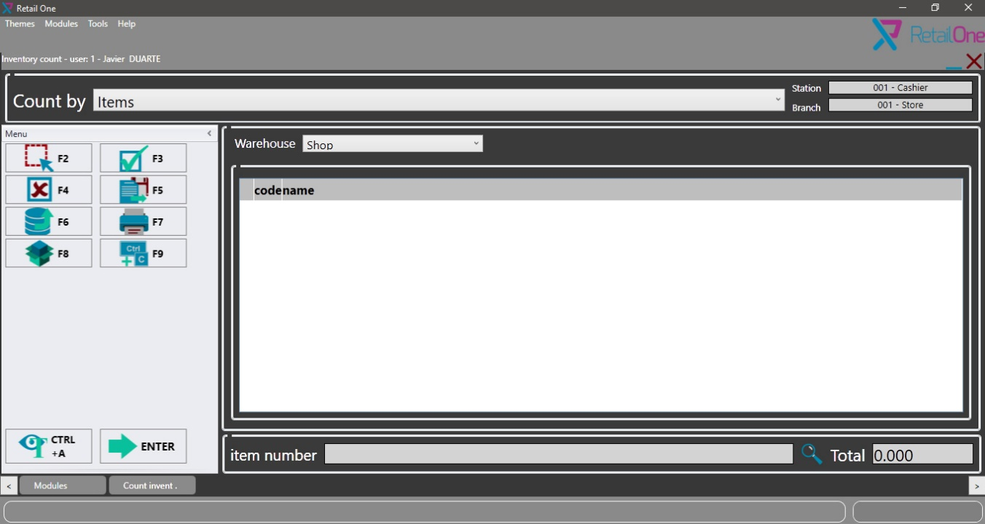

If the count is by Department or Line the table is charged automatically, else we need scan barcode or itemcode.

Next with F3 or balance button, we can change quantity.

Once all quantities are correct click on ESC button.

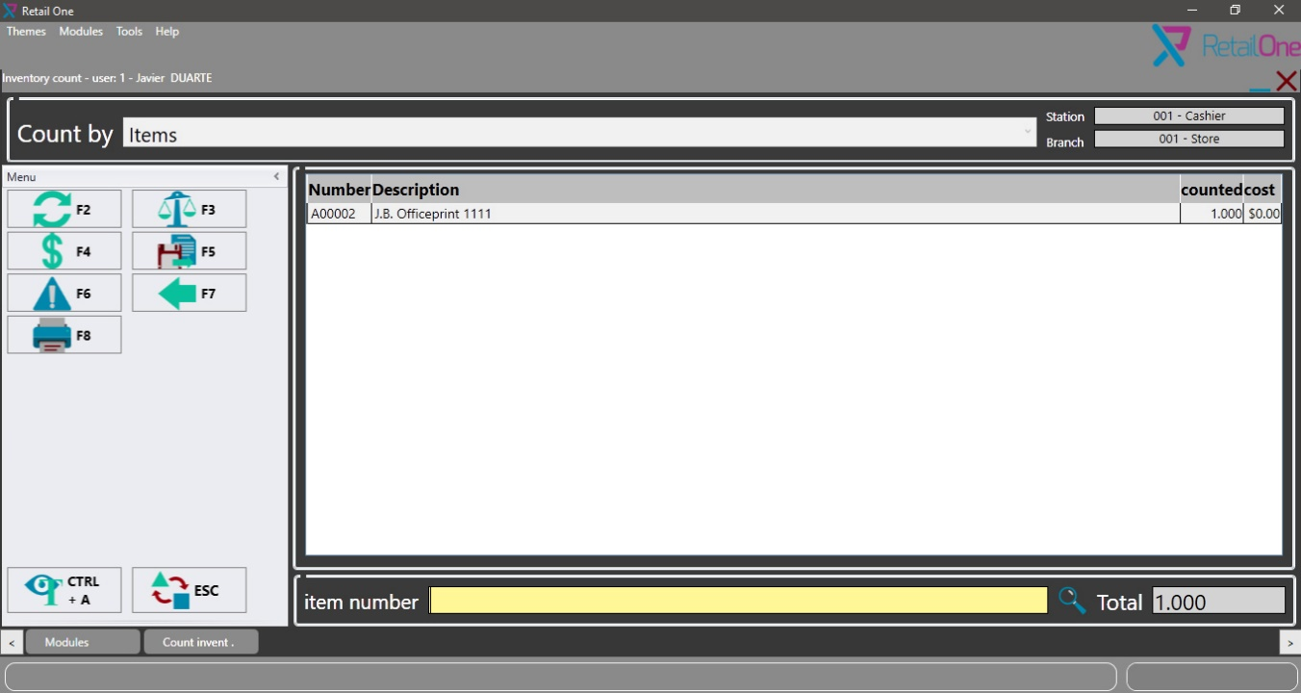

In this screen, we can visualize differences in stock.

If there is difference, we click on ESC button for do the adjustment automatically.

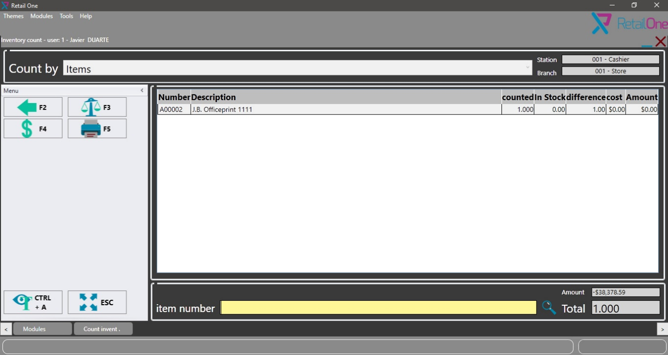

REPORTS

This section is an essential reports compilation with information like sales, inventory movements, etc.

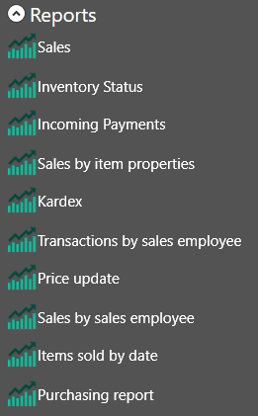

ADDITIONAL

All print formats are in Crystal report format (RPT), the reports have a dataset configured, we can't change the dataset structure.

For enter in all modules, we need introduce user, password and have authorization for enter.

all transactions are sent to SAP in real time if is online, we can work offline and synchronize when return connection.